# Creating a new instance





| **Colour of box** | **Field** | **Description** |
| --- | --- | --- |
| Orange | Product Name | Name of instance |
| Green | Key Pair | Credentials to login to instance. Keep this file in a safe location.  Note: Never upload or include this in (public) Github repository |
| Pink | EBS Storage Volume | * Charged by GB//h * Charged 24.7 even when instances are stopped * Terminate an instance to stop storage costs   Note: You have to create a new instance if you previously selected too little storage. |
| Yellow | Instance Type | * Charged when active * Stop instance to stop compute costs * Instance types can be charged without terminating the instance |

Recommended:  
EBS Storage Volume:

Instance type: Any (Preferably medium)

Once the above values are set, click on the red box in the top right hand corner to launch the machine. This process takes about 10-15 minutes.

# 

# 

# 

# Accessing AWS instance



Start a Ubuntu instance by clicking on the Green Box



Click on the Green Box to obtain the IP address



The Green Box shows the IP address. Copy this address.

In Command Prompt (Windows) / Terminal (Mac) / Ubuntu (Linux), enter the following command:

| sudo ssh -i <PEM file> ubuntu@<IP ADDRESS> |
| --- |

<PEM file> is the location where the KeyPair .pem file is stored   
<IP ADDRESS> copied from the previous step

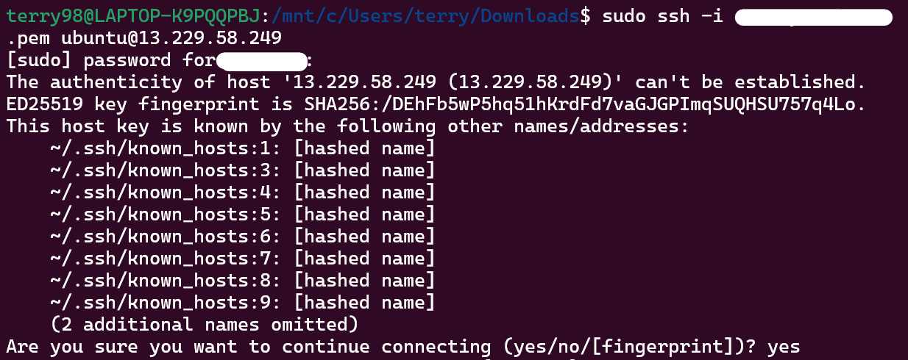

After running the command, you should reach this stage. Enter **yes**.

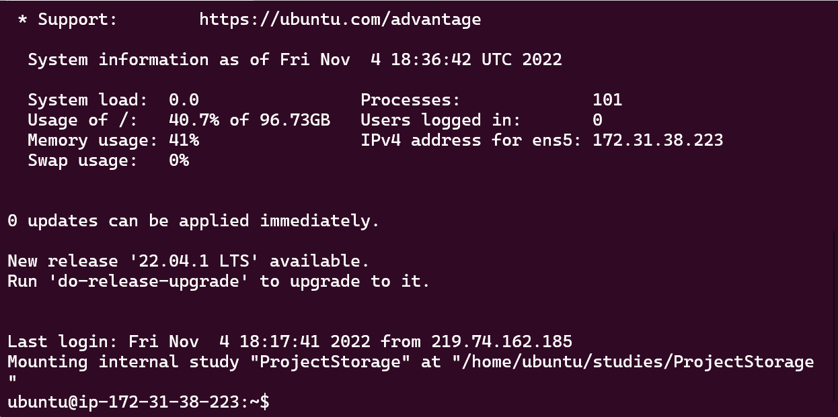

Congratulations! You are now successfully inside the AWS instance! 🎉🎉🎉